|  |
| --- |
| **NAME**: MICHELLE MWANGI  **REG-ID**: CIS-1-2975-3/2021  **UNIT**: E-COMMERCE  **CODE**: CISY 428  **DATE**: 10th JUNE 2023  **PROJECT NAME**: MIRIO JEWELERS |

**MIRIO JEWELERS**

**Description**



This project is a jewelry sales site that facilitates a platform for different vendors to register and showcase their jewelry collections through pictures. Customers can browse the collections, make purchases, and complete payments.

The code in this project utilizes fetch requests to retrieve jewelry data from the server. It dynamically creates jewelry cards to display the collections of various vendors. Users can add their favorite jewelry items to a favorites list and remove them as needed.

Additionally, the project includes robust form submission and validation functionalities. Vendors can register by submitting their information, including details about their jewelry products. The form ensures that the required fields are filled and validates the input data before sending it to the server for registration.

**Main Features**

* **M-PESA Integration:** Customers can purchase jewelry items, paying via M-PESA.

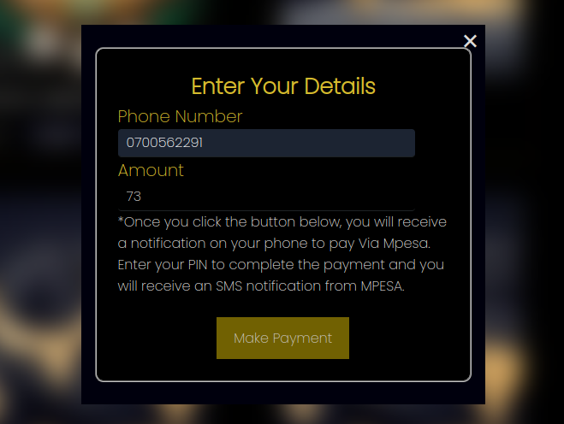

* **Jewelry Vendor List**: View list of all vendors in a sliding carousel.

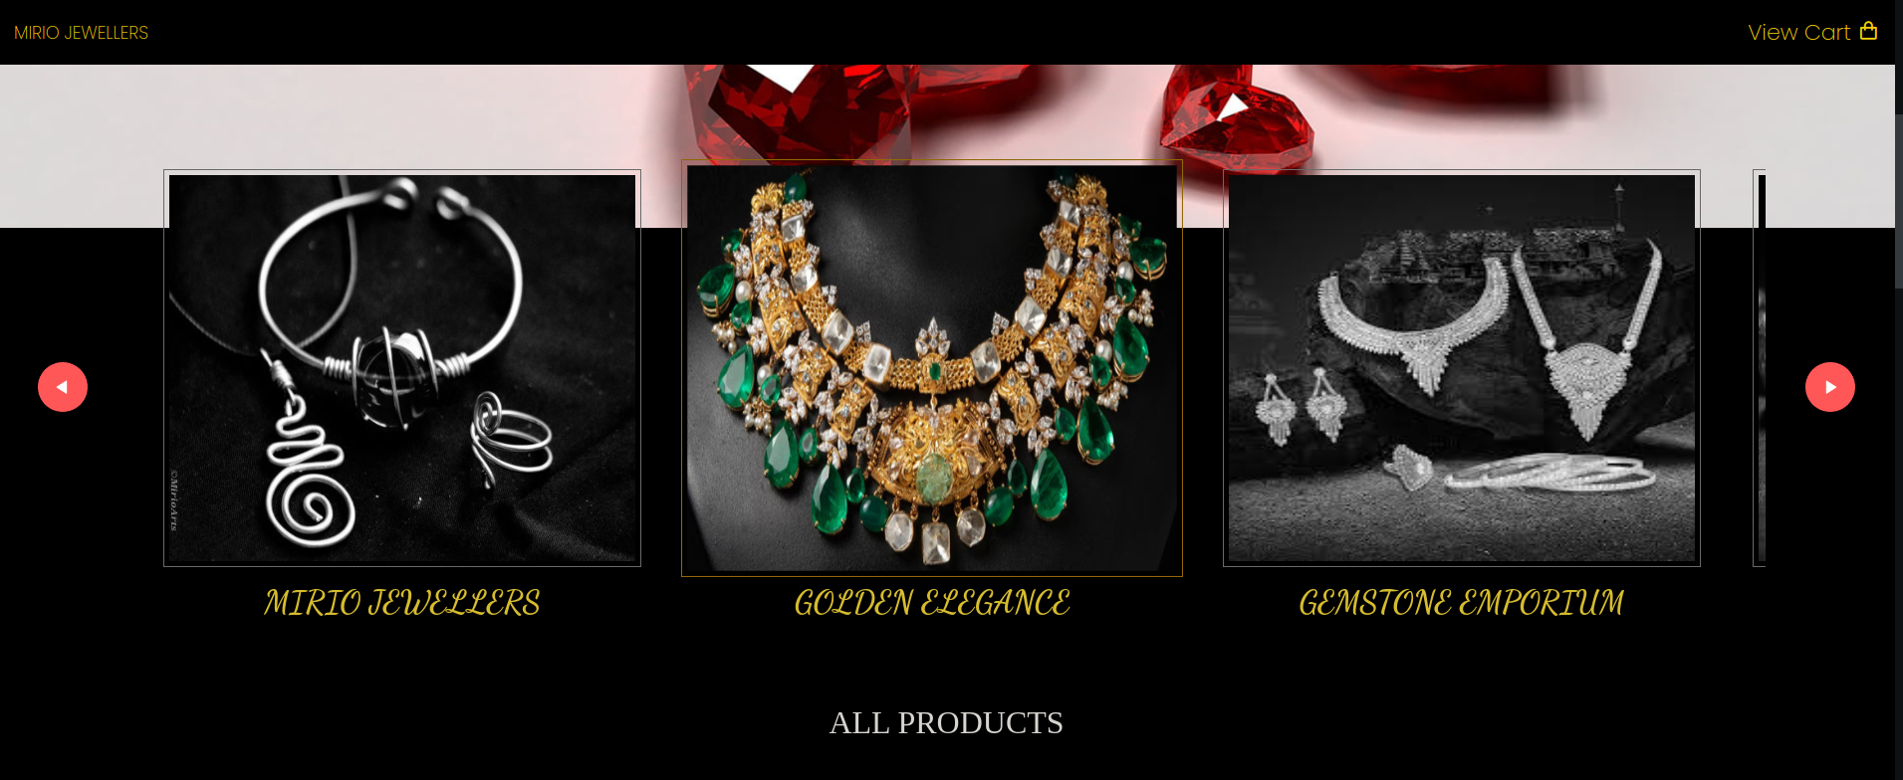

* **Collection Gallery:** View the collection of all items for sale.

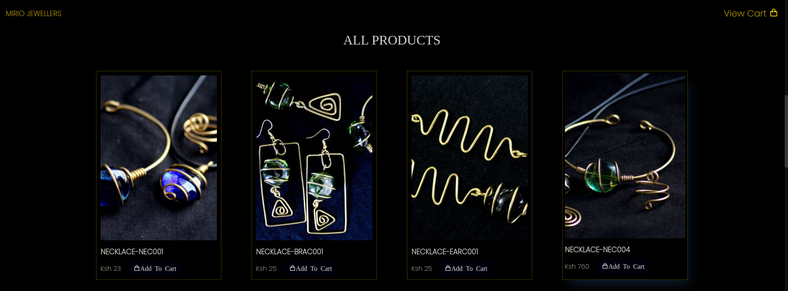

* **Filter Gallery Items Per Vendor**: Gallery can be filtered per vendor by clicking on each vendor image card.
* **Register as a new vendor**: New vendors can register to sell products on the platform.

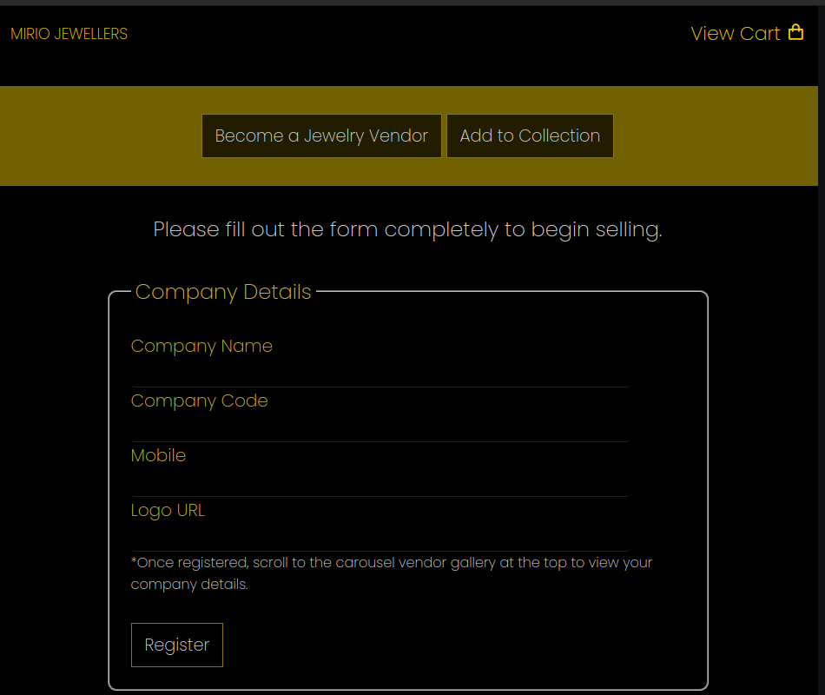

* **Vendors can add items to their collections:** Vendors can add jewelry items to their collections.

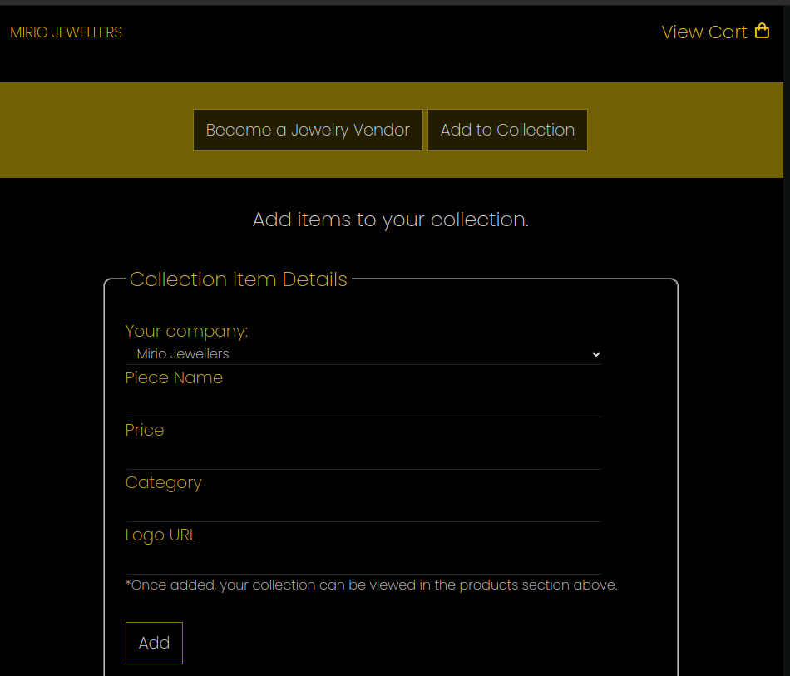

* **Add to cart:** Items can be added to cart and checked out for payment.

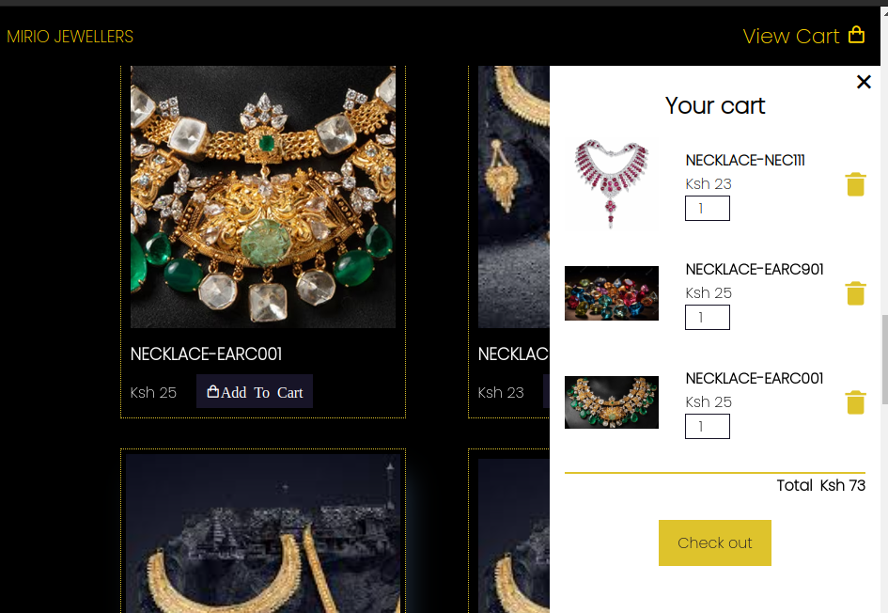

**Setup and Usage**

To use this code, follow these steps:

Follow the link *https://mirioarts-shop.netlify.app/* or clone and deploy the repository locally.

**Dependencies**

This program depends on the external hosting service offered by render.com for hosting the database. It is also dependent on an M-PESA 3rd party API. It uses standard HTML, CSS, and JavaScript and a db.json for the database.

**Credits & License**

This code was developed by and is licensed to Michelle Mwangi. It utilizes the Fetch API for data retrieval and manipulation.

**Issues and Contributions**

If you encounter any issues or have suggestions for improvements, please create an issue in this repository.

**Contact**

For any further questions or inquiries, please contact *michellemwangim.@gmail.com*.